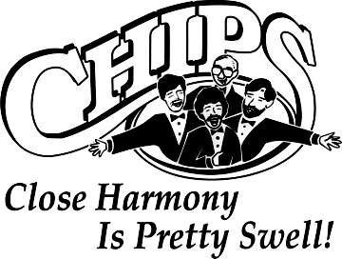
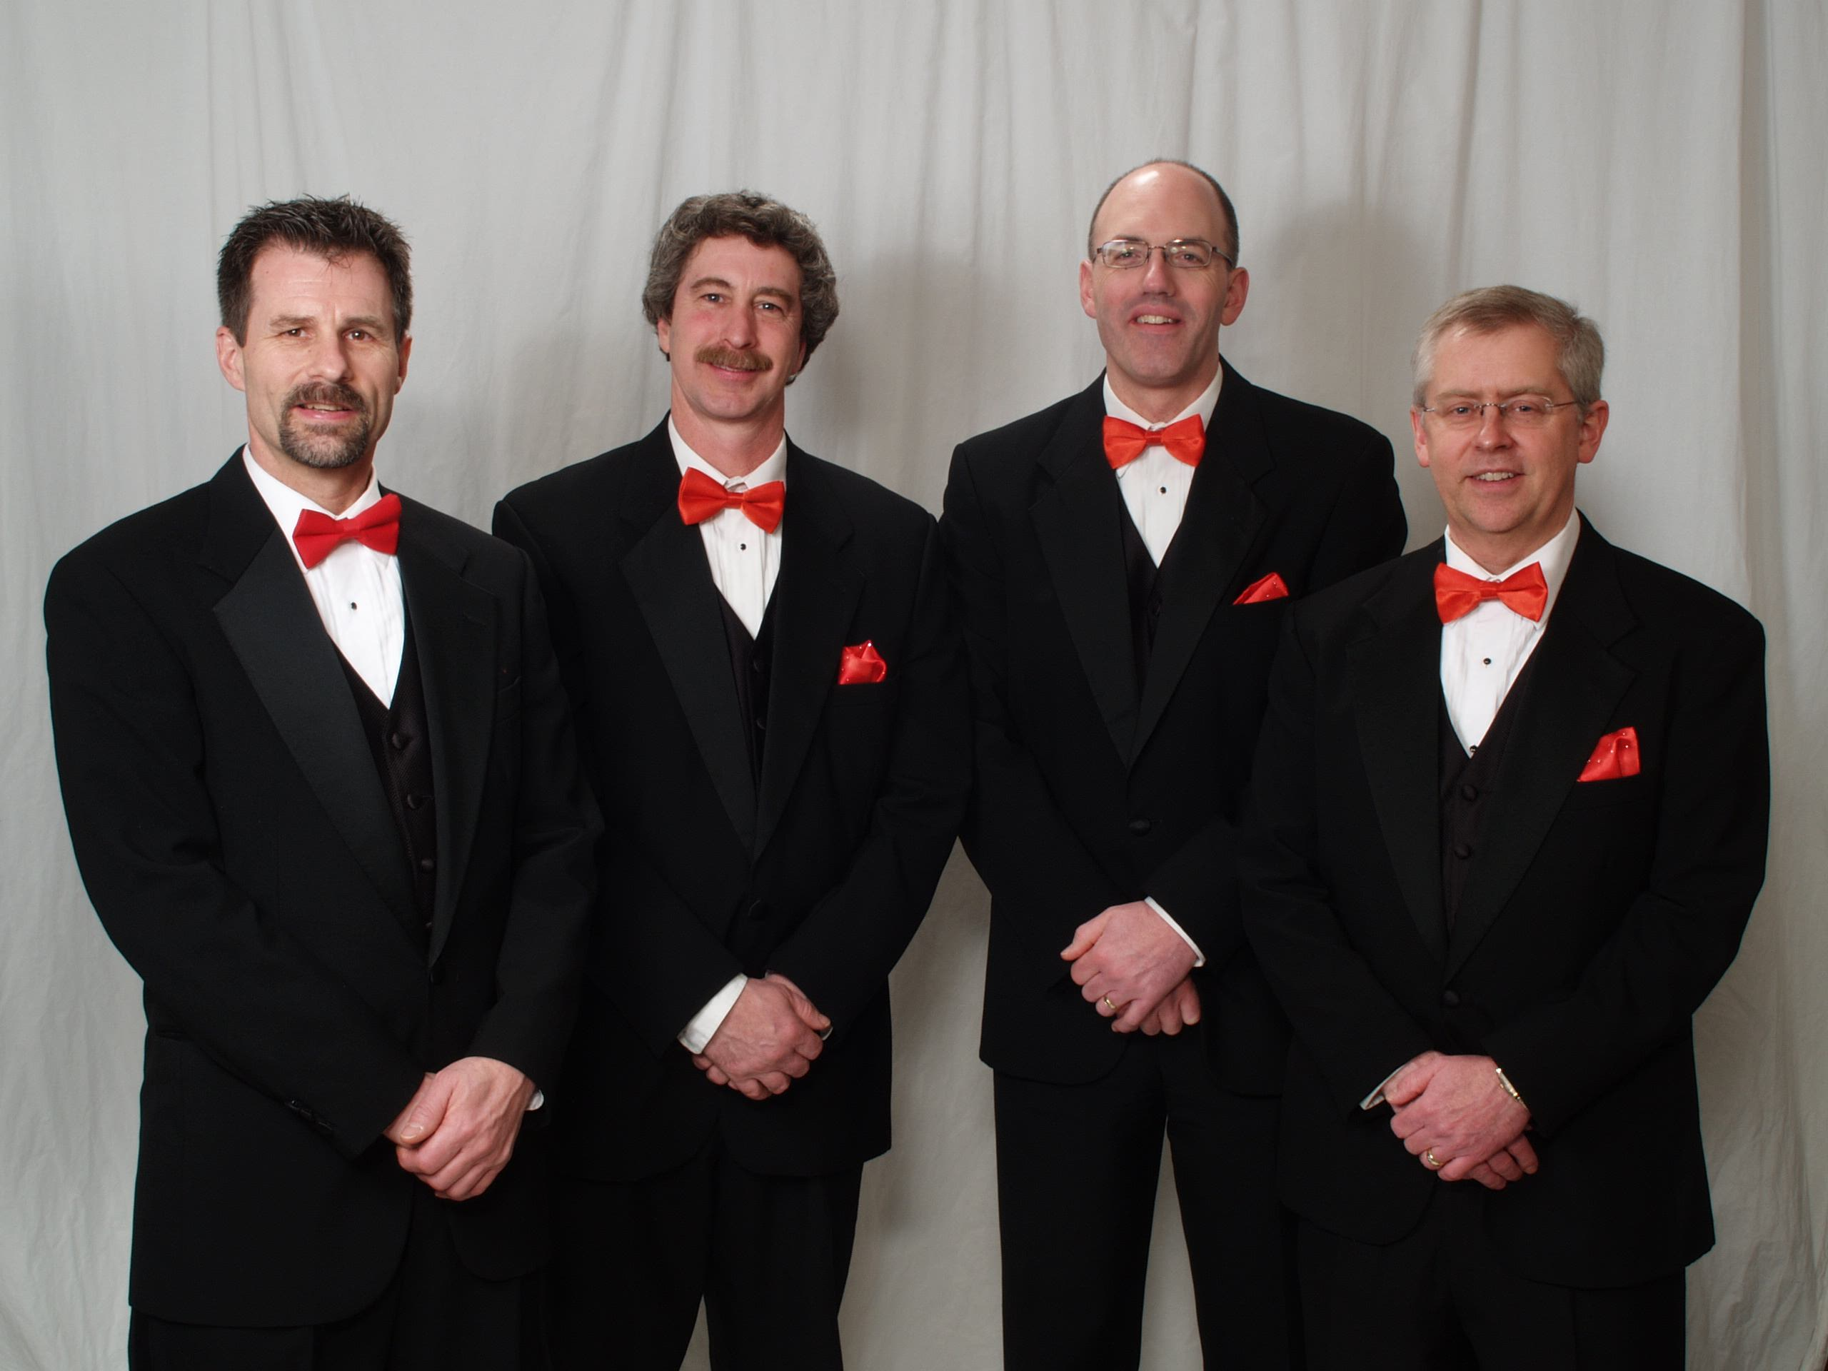
Web: www.ChipsQuartet.com Jerry O'Brien, Eau Claire
Email: info@ChipsQuartet.com Randy Knaack, Menomonie
Phone: 715-726-4074 Steve Hein, Chippewa Falls
Snail: 1900 Eagle Street, Tom Arneberg, Chippewa Falls
Chippewa Falls, WI 54729 (Rev. 01/2013)

CHIPS Quartet Repertoire List

Show openers:
A Almost Like Being In Love
B Chatanooga Shoeshine Boy

Slow songs/ballads:
F What'll I Do
Gb Sentimental Journey
B Pennies from Heaven
Eb Cop on the Beat
Ab Wonderful World
G Danny Boy

Songs with female quartets:
F Lida Rose (w/soprano)
Bb Anything You Can Do

Patriotic/Spiritual:
A Star-Spangled Banner (E)
Novelty/Misc. songs:
G Goodnight, Sweetheart
Gb Silhouettes
C# Sixteen Tons
G Paper Moon
Ab Boardwalk/409

Show closers:
F Irish Blessing
F Darkness on the Delta
Em Can You Tame Wild Wimmen?
A Sold! (Grundy County Auction)

Barberpole Cats (short/simple):
Ab Heart of My Heart
Bb Let Me Call You Sweetheart
Bb My Wild Irish Rose
Bb Shine On Me

