
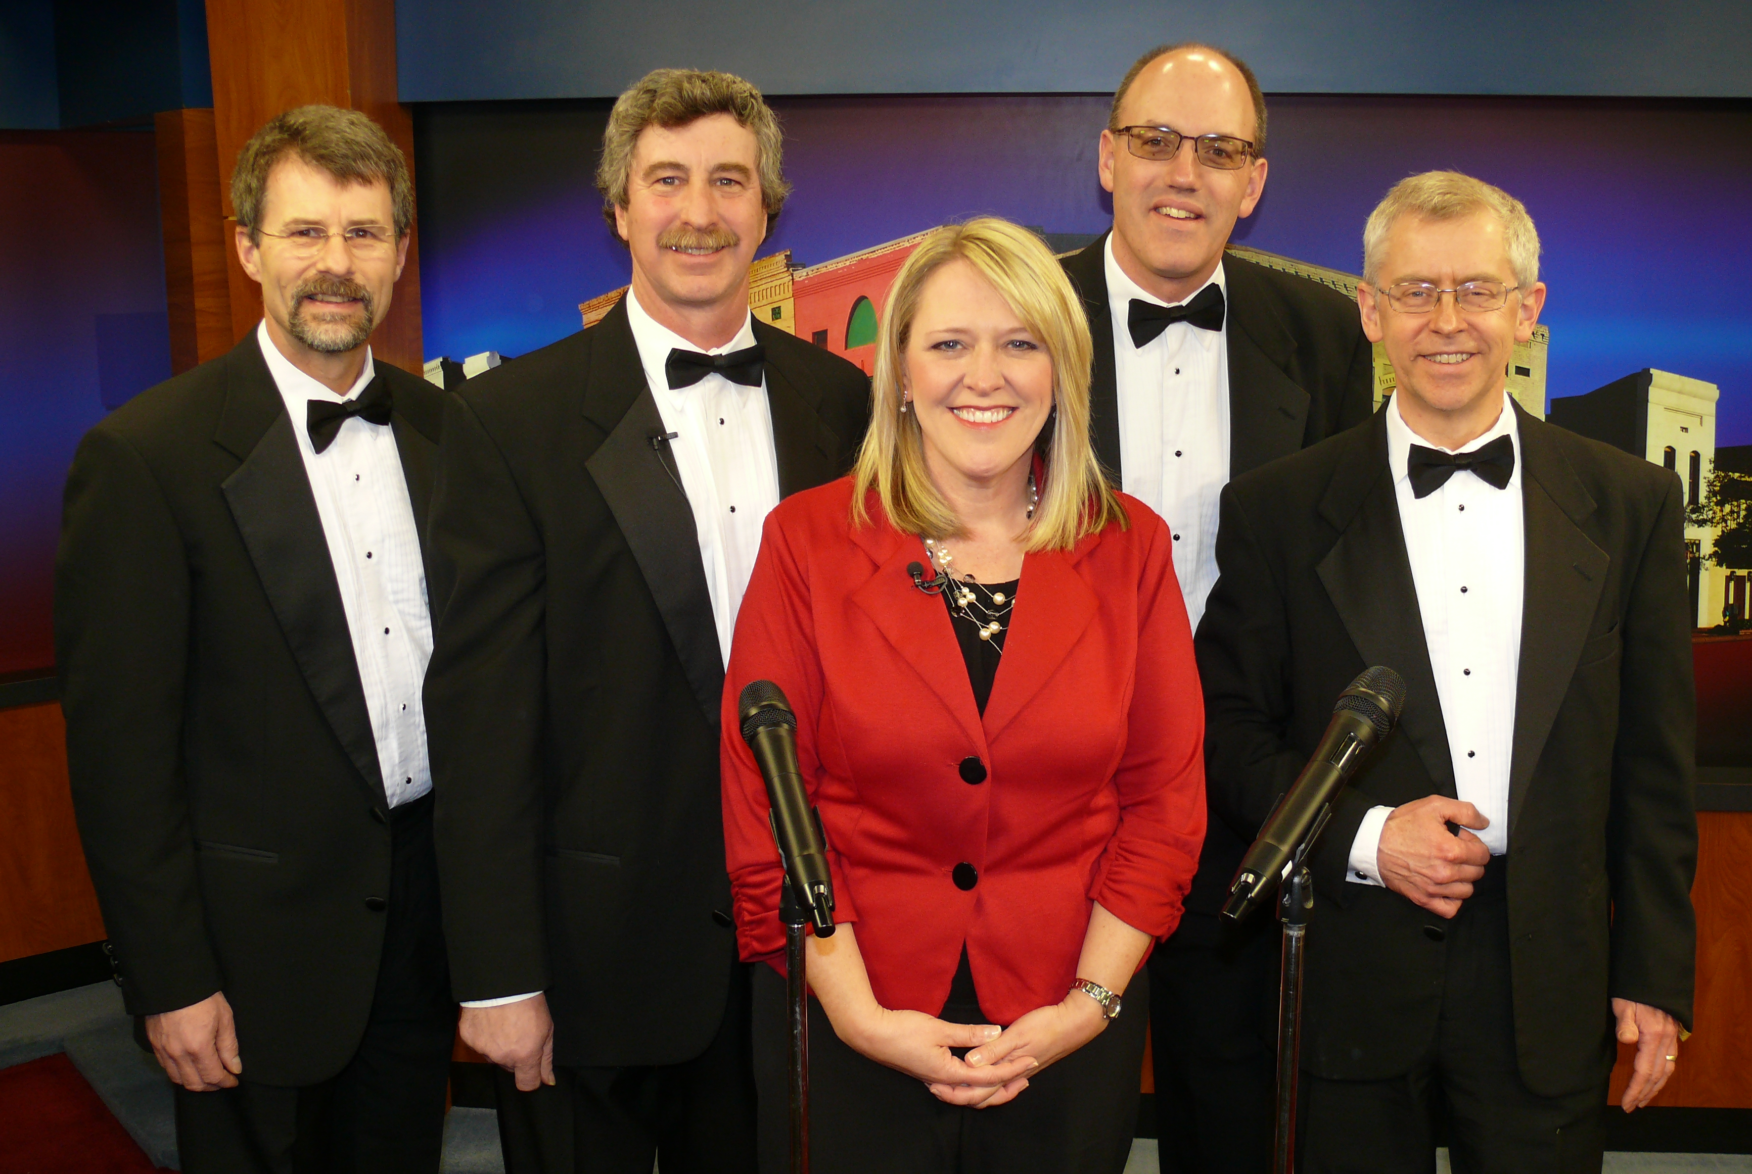
Web: www.ChipsQuartet.com Jerry O'Brien, Eau Claire
Email: info@ChipsQuartet.com Randy Knaack, Menomonie
Phone: 715-726-1728 Steve Hein, Chippewa Falls
Snail: 1900 Eagle Street, Tom Arneberg, Chippewa Falls
Chippewa Falls, WI 54729 (with Judy Clark on WEAU-TV) (Rev. 04/2015)

CHIPS Quartet Repertoire List

Show openers:
A Almost Like Being In Love
Eb Brand New Day
B Chattanooga Shoeshine Boy

Slow songs/ballads:
F What'll I Do
Gb Sentimental Journey
B Pennies from Heaven
Eb Cop on the Beat
Ab Wonderful World
G Danny Boy
F The Rose

Patriotic/Spiritual:
A Star-Spangled Banner (E)
C Your First Day in Heaven
Gb Run, Run, Run

Barberpole Cats (short/simple):
Ab Heart of My Heart
Bb Let Me Call You Sweetheart
Bb My Wild Irish Rose
Bb Shine On Me

Novelty/Misc. songs:
G Goodnight, Sweetheart
Gb Silhouettes
C# Sixteen Tons
G Paper Moon
Ab Boardwalk/409
F Lida Rose (w/soprano)
A Book of Love (I Wonder)
Ab Hello, Mary Lou
G How Can I Miss You (If You
Won't Go Away)?
Em Happy Together
D Longest Time

Show closers:
F Irish Blessing
F Darkness on the Delta
Em Can You Tame Wild Wimmen?
A Sold! (Grundy County Auction)

